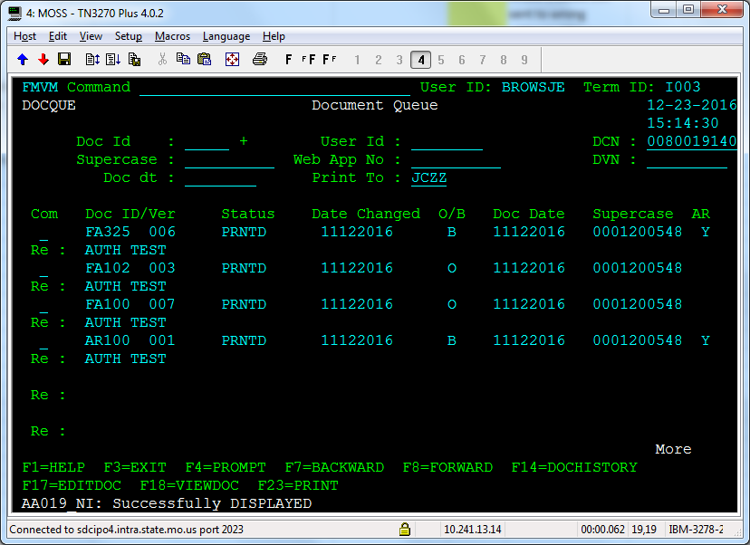

B indicates batch, O indicates online

New field to indicate notice was sent to the authorized representative

Y indicates the notice was sent to the authorized representative

