Content Locker for iOS End User Guide

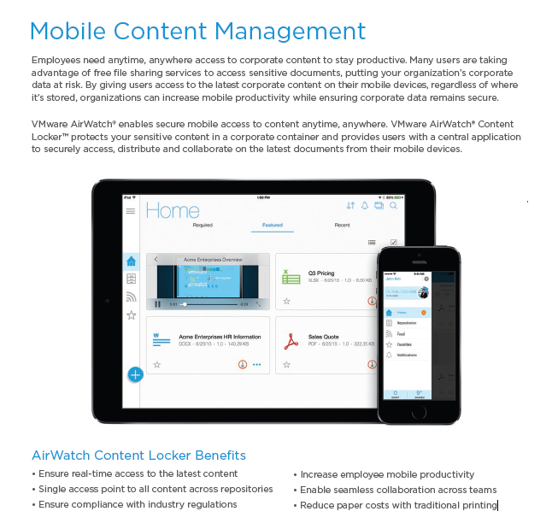

Navigating Content Locker
Content Locker centralizes all your enterprise data in a single container and integrates existing content repositories on your mobile device. Toggle between the available screens to access and manage files. Using FIPS 140-2 encryption, you can securely open, edit, store and manage content on your device wherever you are.

Installing the Content Locker onto your mobile device

- Connect to WIFI – Because the app is over 100mb, this is a requirement
- Open the AirWatch Catalog and search for the AirWatch-Secure Content Locker app
- Click on Install
  - This is a large app that might take some time to download and install
- Once installed you will notice an app named “Content” on your device

Opening and Signing into the Content Locker

- Open the Content Locker app
- Click OK to allow sending of notifications
- Enter your username as you would when logging into your computer without the domain
- Enter your password as you would when logging into your computer
  - If your device supports Touch ID then you can set that up to log into the app
- If available, open a repository and log in using the same credentials you used above without the domain

Offline View and Access
Certain times your mobile device will be offline. If you are aware that you will be offline and would like to still edit or view selected files then you will be able to for a limited amount of time.
- Offline access on a mobile device is set to 4 hours. After that amount of time of being logged into the Content Locker you will be locked out until your device connects to the Internet and you reauthenticate into the app
- See Managing Content on page 5 to download files to your device for offline access

NOTE: If you modify or create documents or take pictures from within the app while offline they will not automatically sync to your network storage until you sign back into the Content Locker while online and perform a manual sync. Do this by either nagivating to the location where the document is on your device and pulling down on the screen until you see a spinning wheel at the top of the screen or by clicking on the icon to sync the item with the network location.

Understanding the Home View
The multi-functional Home view is the first screen you see after you open Content Locker. It displays high priority content and serves as a central navigation location.

High Priority Content
High priority content distinguishes content that requires special notice into defined categories.
Icon Definition  Required View content your administrator marked as required. Not currently used  Featured Access content your administrator flagged as important  Recent Access recently viewed or updated files.  Side Navigation  Access any of the following options from the side of your screen:  Icon Definition  Access to find application information and settings.  Access admin selected Content Types in the app’s default view.  Access and view content stored on your corporate network as well as content you uploaded to the cloud.  View the content you bookmarked for quick access.  Add new documents, media, folders, or repositories directly in the app. | 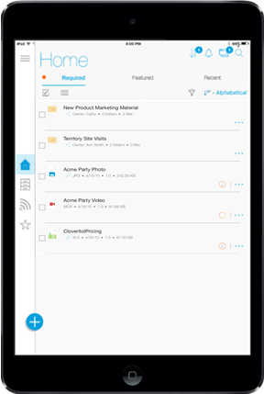
Top Navigation
Access any of the following options from the top, right-hand corner of your screen:
Icon | Definition
 | View active downloads and uploads as well as download and upload history.
 | View updates, collaboration, and alerts.
 | See currently open documents.
 | Perform a global search of all content.

Understanding Repositories
All content is stored in your organization's repositories where you can add files and folders needed. You may access one or more repositories depending on how your administrator set up this up for you. Use the bread crumbs to navigate repositories and folders.
Some repositories are automatically assigned and others will need to be added manually. If you don’t see a repository that you think that you should be seeing then click on the + icon and click on repository. Type the path to the share in the field and click on continue. Example - \\sditaiw1697\mobile In this example we have included the server and the name of the share. The mobility team must grant access to the share before it can be added to your mobile device. Please check with your department mobile coordinator to see if you have access or to the share.

Searching and Sorting Content
Tap these icons to use as tools to search and filter for content. These tools appear on any of the screens where content is available.
Icon | Defintion
 | Enter keywords into the search bar to perform a global search of all content. Or, choose additional filters, or a Location to do a granular search.
 | Select multiple files and manage bulk actions. Tap the to de-select bulk management.
 | Change the card view to a list view on that screen.
 | Change the list view to a card view on that screen.
 | Set filter preferences and apply them to content search results.
 | Sort icons based on the alphabet (ascending or descending), modified date, priority, and size.

Adding Content
Use Content Locker to securely add and maintain content.

Creating New Content
Tap the button to add content. This button appears on all of the content screens so that you can add new content any time.
- Creating content from Home, Activity, or Feed screens – You will be asked where to save your new content.
- Creating content from a Repository – Your content will be saved directly to that repository.

The following table explains the types of content you can add.
Type | Defintion
Document | Add Word, Excel, Powerpoint or Text files. Edit the files and then name and save the document appropriately.
Media | Add one or more photos and videos by filling out a form with a Subject (required) to save and identify content later, then select Continue to Add and Import the photos or videos. Or, capture audio and save it appropriately.
Folder | Add a folder and select a repository to save the folder.
Repository | Enter a repository link, select Continue to complete the process.

Using Open In Functionality
Use Open In functionality to open email attachments or files from your web browser.
- Email attachment – Tap the attachment link and tap Open In… > Copy to Content, which appears in the top-right corner of the screen or an “Open in Content” link appears for Microsoft Office documents and the document opens in Content Locker. Then, save the document appropriately.
- File in the browser – Tap the file and choose Open In… > Copy to Content and the document opens in Content Locker. Then, save the document appropriately.

Managing Content
View and manage content directly in the app. Use the content cards or the content list vew to find information about each document including the date the document was created, the version number, and file size and type. Use the icons on the content cards as tools to organize and personalize the content. Or, use bulk actions to organize many files at once.

Managing Individual Content Cards
Tap the icons on each content tile to perform actions or access additional functionality.
Icon | Defintion
 | Add to your Favorites list. Tap again to remove it from your Favorites list.
 | This icon indicates that you saved the document as a draft. Draft are stored locally on your device. You can acesss them any time by viewing drafts in the User Hub. Drafts are not yet synced to a repository.
 | This icon indicates that content was updated.
 | Use this menu to find information, delete, rename, collaborate by commenting or sharing (if available), use open in functionality (if available) to send the document as an email attachment or with another secure application, or add content to Favorites.
 | Download content from a Personal Content repository or a Corporate Content repository to the device.
 | Upload content or sync with your enterprise network.
 | Content is in the process of downloading to the device.

Managing Multiple Content Cards Using Bulk Actions
Select multiple files or folders and use the actions on the left-navigation bar to simultaneously perform actions on the documents. Unavailable actions appear in grey and are not usable.
Icon | Defintion
 | Tap to select files to group together to perform bulk actions. A check mark appears.
 | Add to your Favorites list.
 | Email the file using the native mail client to another employee.
 | Copy the file in the selected folder or create a New Folder for the copied file.
 | Delete the file. A prompt appears asking for confirmation.
 | Exit the bulk action functionality and return the content screen.

Editing Content

Using the Microsoft Office Viewer
After opening an Microsoft Word or Excel document, you can edit it directly in the app to ensure it is protected alongside your other corporate data. Use the following tool bar to edit files.
Icon | Defintion
 | Undo and redo actions as needed.
 | Take pictures or add images. Or, add shapes, tables, charts, or cells.
 | Use these menus to format the document after selecting an object or text.
 | Use this menu to save the file, use find and replace functionality, open into (if available), or perform actions related to the file type.
 | Use this menu bar to copy formats, add comments, hyperlinks, footnotes, or endnotes. These icons appear after tapping on the Word document.
 | Use this menu bar to cut the cut, copy, or delete the images, add a hyperlink, change the image, or re-size and rotate the image. These icons appear after tapping on the image. To see the hyperlink, bring up this menu, and tap Open Hyperlink.
 | Use this menu bar to crop the image and accept or reject the size. This menu appears after you tap on the image twice.

Saving Microsoft Office Files
Tap the menu icon and then follow the prompts to decide how and where you want to save the file. An Import window appears with the following options:
- Save File as a New Version. The file name remains the same but a new version number is added to the content card. (The availability of this option is determined by the repository settings.)
- Save As a New File with a new version. Edit the New File Name and Location if desired.
- Save As a Draft which appears on the screens and is saved to the User Hub but not synced to a repository. A draft icon appears next to the file status. To move the document out of draft status, save the document as a new file.
After saving, tap the arrow icon in the navigation bar at the top of the screen to return to where you last accessed content.

Using the Adobe Acrobat PDF Viewer
After opening an Adobe Acrobat PDF document, you can annotate it directly in the app. Use the following tool bar to annotate files. Each open PDF appears in a row of tabs across the PDF viewer.
Icon | Defintion
 | Add this document to your Favorites list.
 | Comment on the file to share with collaborators. Type @ in text box and identify the receipients using email addresses. Press Send to complete the process.
Use the editing tool bar that appears on the left-side of the screen to annotate the document as needed. Tap to select icons and tap again to de-select the to move between the tools.
Highlighted features include:
- Sign file – Long-press the text box icon to add a signature to the document.
- Stamp file – Long-press the image icon to add a stamp to the document.
 | Add annotations to the document, view the outline, or add bookmarks.
 | See thumbnail views of all the pages in the document.
 | Search the open document for key words.
 | Open the document in another application. If the document is restricted, you cannot open the file anywhere else but you can find information about the file.
 | Use the Search Hub to to access all documents in your content repositories.

Saving Adobe Acrobat Files
Tap the disk icon that appears in the navigation bar at the top of screen after you annotate the file. Follow the prompts to save changes. A window appears with options for saving:
- Save File as a New Version. The file name remains the same but a new version number is added to the content card.
- Save File as a New File with a new version. Edit the New File Name and Location if desired.
- Save File as a Draft, which is saved to the User Hub but not synced to a repository. A draft icon appears next to the file status. To move the document out of draft status, save the document as a new file.

After saving, you can close the document by tapping the X in the tab, or tap Back to return to the content screen where you last accessed content.

