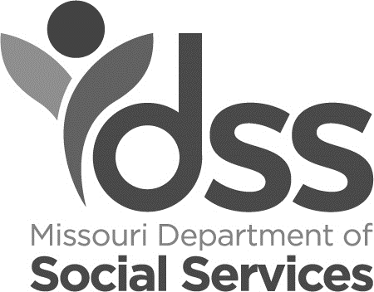

Applying for SNAP Benefits
Need Help?
- By phone: 855-FSD-INFO
(855-373-4636)
•
•
Online: mydss.mo.gov
In person: Visit any FSD
Office. To find an office in your area, call the number above or visit us online.
You can start your Supplemental Nutrition Assistance Program (SNAP) application on your own, or with help from the Family Support Division (FSD):
- To get an application: Visit online, call FSD, or visit an FSD office.
- Fill out as much of the application form as you can. If you need help, contact the FSD.

Proof to Include for Faster Service
Below is a list of some proof you can turn in with your application for each household member for which you are applying. Providing this may result in a faster decision on your SNAP benefits. Only send copies - do not send the originals.
- Still apply if you don’t have this verification and FSD will help you.
- These are only examples and you can send other information.

Identity
No identity proof is needed if you have a Missouri Driver License. If you do not have a Missouri Driver license, you can turn in one of the following:
- Driver license (any state)
- Identification that is not a driver’s license, such as a military, work, or school ID card
- Voter registration card
- Birth certificate
- Pay stub showing wages from a job
- Passport
- Medical insurance ID card
You can also visit any FSD Office with anyone to tell us who you are and not provide the above.
Residency (if questionable)
To show residency, you can turn in one of the following:
- Written lease agreement
- Letter from your landlord or a person you are paying to live with
- Rent or mortgage receipt
- Phone, water, or other utility bill
Immigration
To show immigration status if you or any other household members are not United States citizens, you can turn in one of these for each person who is not a U.S. citizen:
- Birth certificate
- Letter from Canadian Department of Indian Affairs
- Certification letter
- Military discharge record (DD214)
- Military ID card
- Order of an Immigrant Judge
- USCIS or other Homeland Security paperwork that shows alien status

Income
You can turn in any proof showing how much each household member got in payments within the last 30 days.
Work income | - Pay stub or employer statement that shows gross income, net income, rate of pay, and how often you were paid
Retirement income | - Veteran’s Benefits or Armed Forces Allotment – A letter that shows the current benefit amount  - Pensions or other retirement plans – A current earning statement, SSA award letter, or summary of benefits
Disability income | - Short term or long term disability insurance – A statement from the insurance company  - Railroad disability – A statement from the Railroad Retirement Board  - Social Security Administration award letter
Alimony income | Only need one of the below:  - Written statement from the former partner  - Court order  - Payment schedule
Child Support | Only need one of the below:  - Written statement from the non-custodial parent  - Court order  - Payment schedule
Education income | - Awards documents  - Grant documents  - Student loan documents
Other income | - Written statement from the person giving you money that states amount and how often it is paid  - Lottery or gambling winnings  - Payments from a trust fund, royalties, rental properties, or a tribe - letter that shows amount and how often it is paid  - Unemployment compensation from another state – letter that shows the current benefit amount

If you have applied for other types of assistance (Temporary Assistance, Medical, etc.) and have been denied you may still be eligible for SNAP.

The Family Support Division is an equal opportunity provider/employer.
The USDA is an equal opportunity provider/employer.

IM-31F (10/2023)

